**Task 4=>Document any findings in bullet point format:**

* **Finding 1=>The Dropdown for Date of Birth field(Geburtstag) is not fit into the pop-up displayed:**
* **Expected Result as per end user=>** The days, month, year should fit in the displayed pop-up or extended accordingly rather than end user scrolling it.
* Other option would be to make the editable field and auto-select the option.

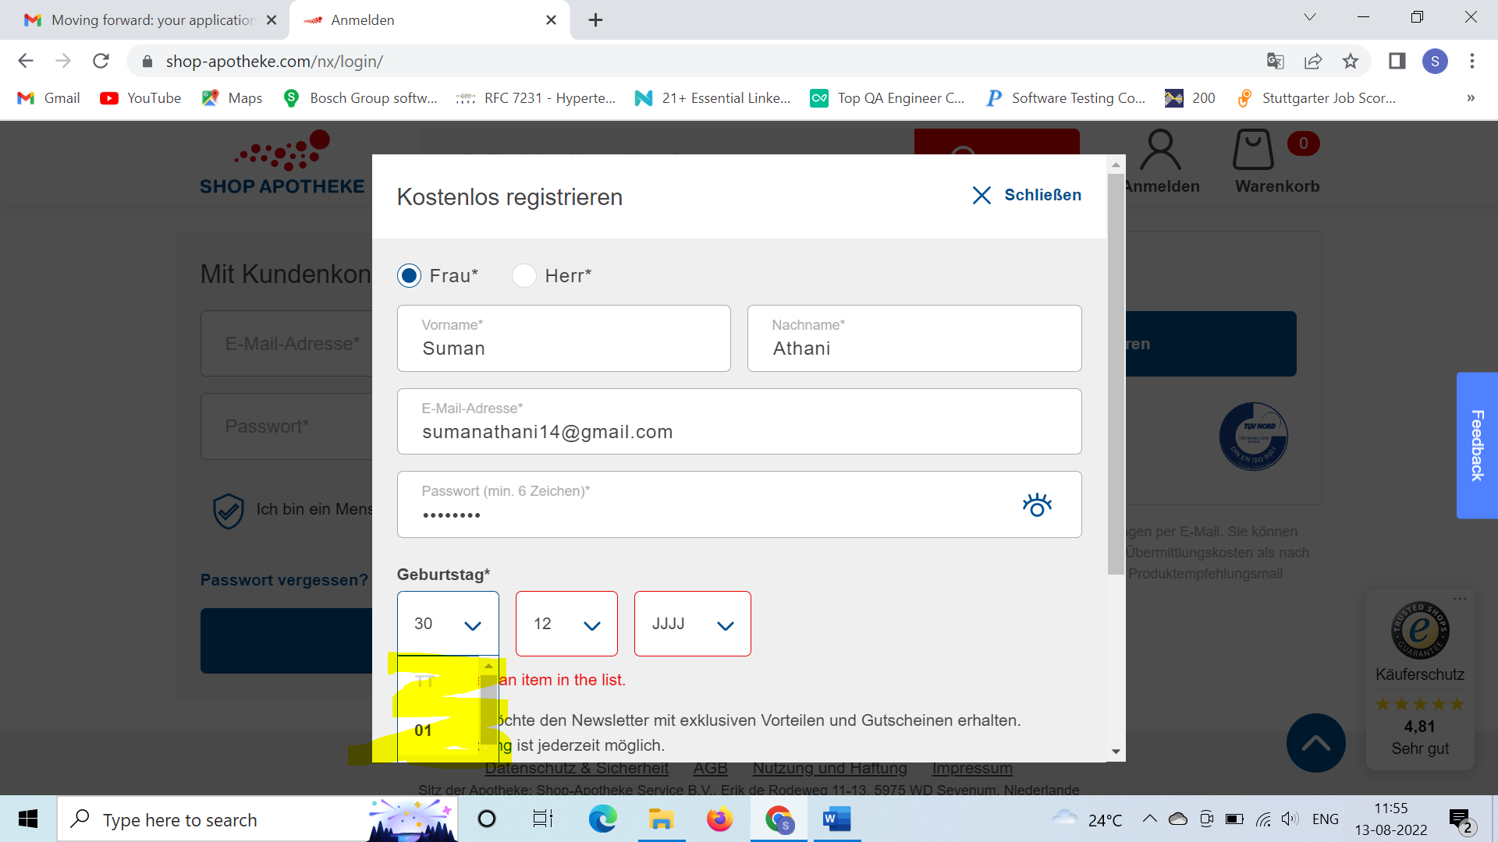

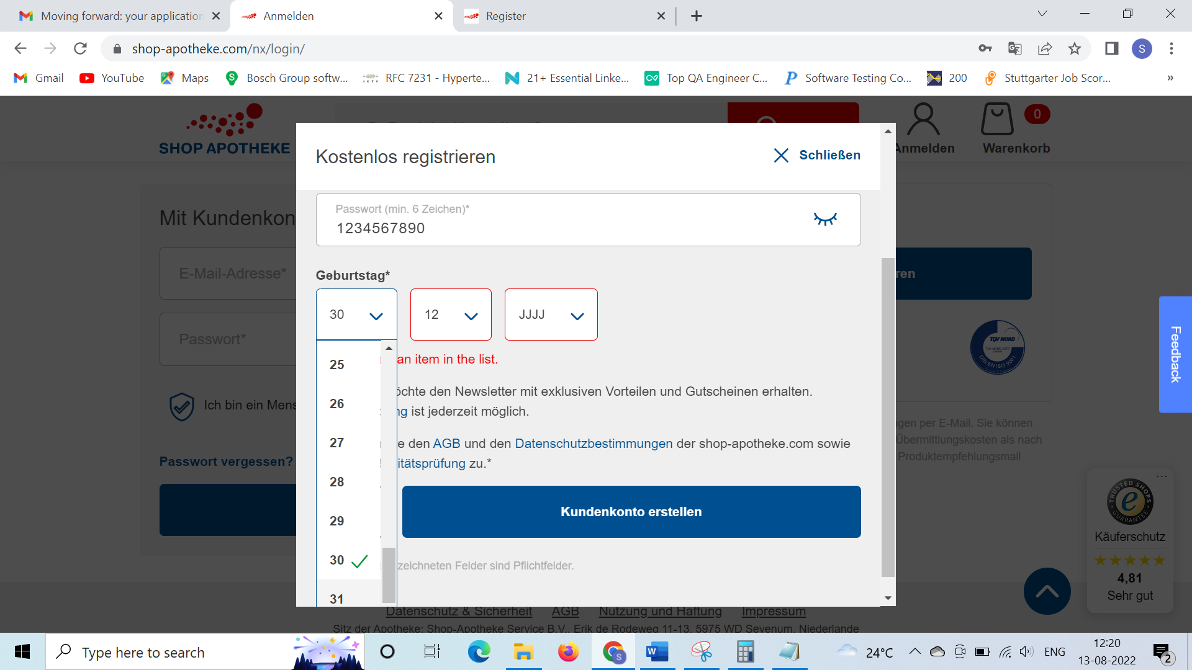

**Finding 2=> Password field(Passwort) did not reset or clear once clicked on cancel button(Schliessen) and reopened:**

**Steps to reproduce=>**User enters some of the values to create new account and cancels it in the middle and clicks on create account again

**Expected Result=>** As per security testing/security reasons, authentic values such as passwords in this case should never be stored and should be reset/cleared and allow end user to re-enter it.

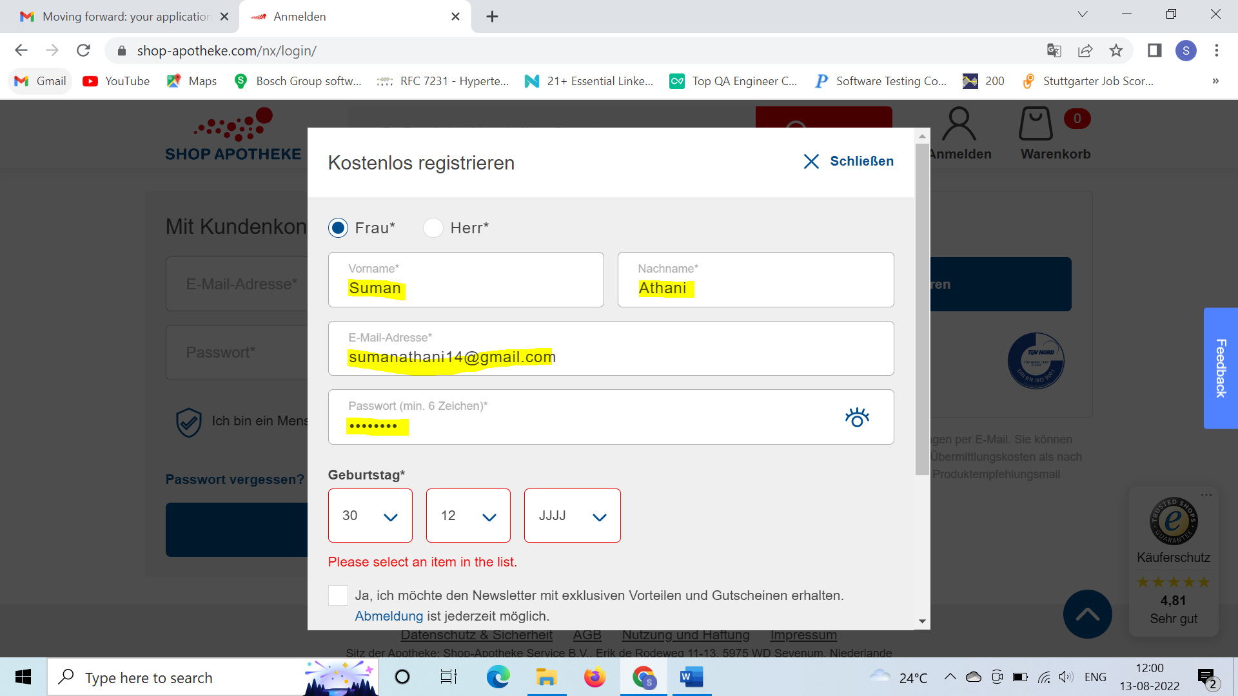

**Finding 3=>Vorname and Nachname allows to create account with only special chars:**

**Finding 4=>Passwort field can contain only chars, numbers .**

**Expected Result as a end user for Finding 3=>** It should not allow to create account with only special chars. There should be only alphabets or combination of alphabets and special chars for these fields.

**Expected Result as a end user for Finding 4=>**As per security reasons, the password field should be restricted to have a combination of chars, alphanumberics, special chars.

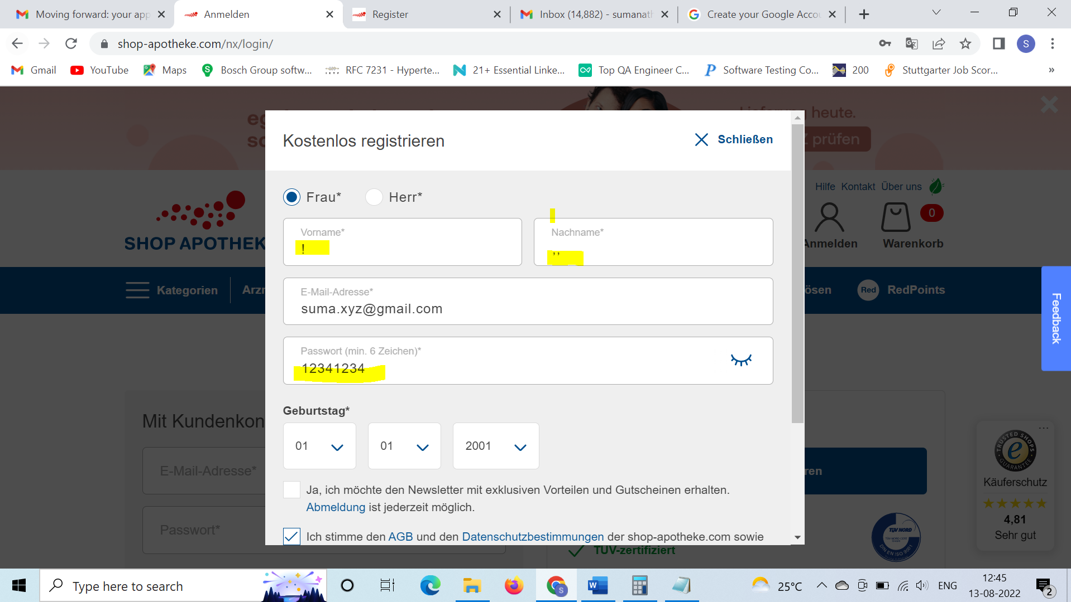

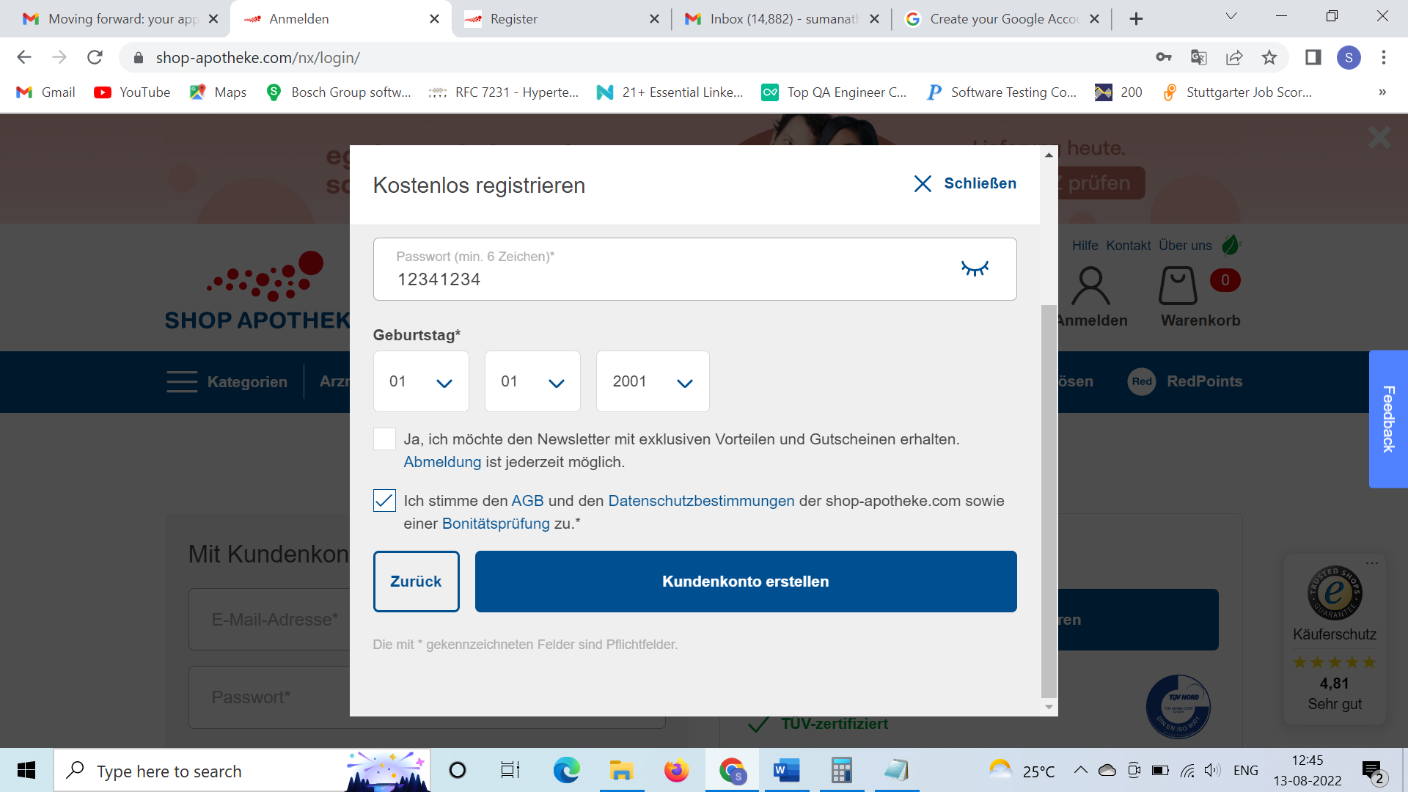

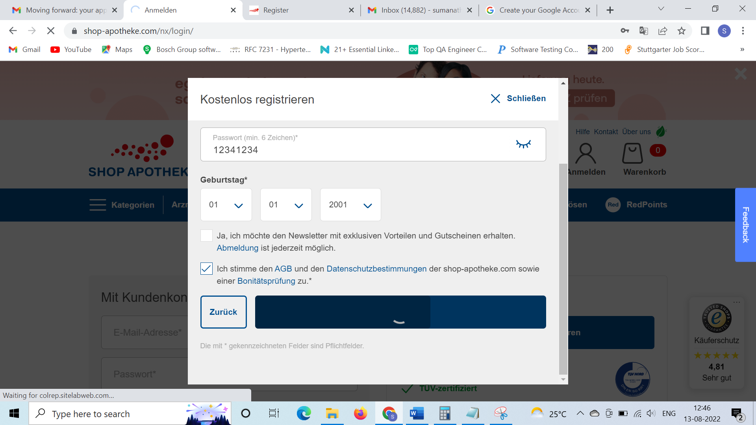

**Account created:**

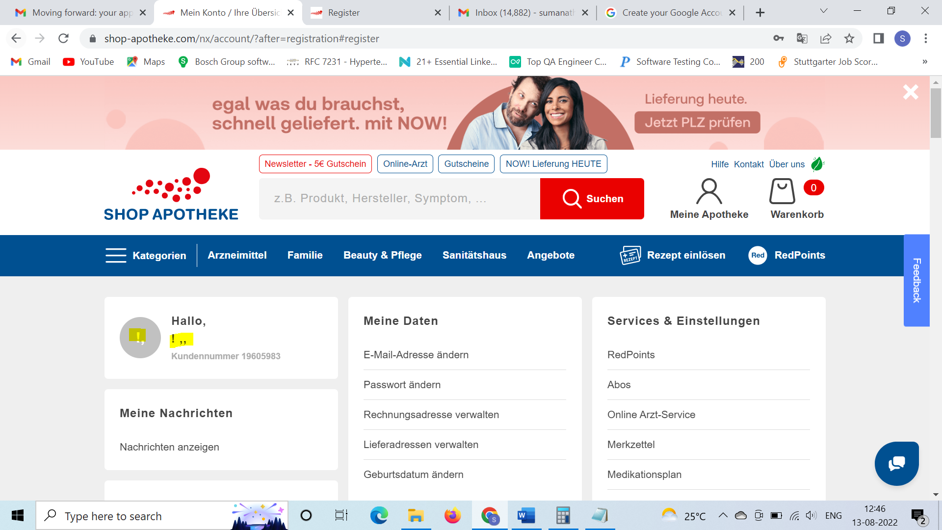

**Finding 5=>”Enter a valid email address” error is displayed even we entered a valid email id such as** [**15log10@gmail.com**](mailto:15log10@gmail.com)

